ID | TYPE | DESCRIPTION | PRIORITY | ACCEPTANCE  CRITERIA | RATIONALE
FR-001 | Functional | The system shall generate optimized daily collection routes including bins that have exceeded an 80% fill threshold. | HIgh | Pass: Route includes all bins above 80% fill. Fail: An eligible overflowing bin is omitted. | Ensures high-priority bins are collected before they overflow.
FR-002 | Functional | The system shall ingest and display ultrasonic fill-level data received from smart trash bins. | High | Pass: The latest fill level of each bin is available. Fail: Fill-level data is not received or displayed correctly. | Accurate and current bin data is required for route planning.
FR-003 | Functional | The system shall allow the Sanitation Supervisor to recalculate collection routes based on updated bin conditions. | High | Pass: A revised route is generated using updated bin data. Fail: The system continues using an outdated route after recalculation is requested | Bin fill levels can change during the day, requiring dynamic route updates.
FR-004 | Functional | The system shall allow the Sanitation Supervisor to record and track citizen complaints for missed pickups. | High | Pass: A complaint can be recorded and its status tracked. Fail: A missed-pickup complaint cannot be recorded or tracked. | Complaint tracking helps identify and resolve missed collections.
FR-005 | Functional | The system shall recalculate routes for 50 trucks and 10,000 bins within 45 seconds under peak load. | Medium | Pass: Benchmark testing confirms route recalculation completes within 45 seconds. Fail: Recalculation exceeds 45 seconds. | Fast recalculation is necessary for efficient fleet management.
NFR-001 | Non-Functional – Performance | The system shall recalculate routes for 50 trucks and 10,000 bins within 45 seconds under peak load. | High | Pass: Benchmark testing confirms route recalculation completes within 45 seconds. Fail: Recalculation exceeds 45 seconds. | Fast recalculation is necessary for efficient fleet management.
NFR-002 | Non-Functional – Security | The system shall ensure that route and operational data is accessible only to authorized users. | High | Pass: Unauthorized users are denied access. Fail: An unauthorized user can access restricted information. | Protects operational information and prevents unauthorized changes.

2)UML Use-Case Diagram
1. System boundary
Draw one large rectangle and write at the top:
Municipal Solid Waste Route Optimizer
2. Actors
Use 3 actors:
Primary Actors
- Sanitation Supervisor
- Truck Driver
Secondary Actor
- Smart Bin / Ultrasonic Sensor System
Place the first two on the left/right sides of the system boundary and the Smart Bin on the opposite side.
3. Use cases inside the rectangle
Create these 8 ovals:
- Receive Fill-Level Data
- Monitor Bin Fill Levels
- Generate Optimized Collection Route
- Recalculate Collection Route
- View Daily Collection Route
- Update Pickup Status
- Report Missed Pickup
- Track Citizen Complaints
4. Connect the actors
Sanitation Supervisor →
- Monitor Bin Fill Levels
- Generate Optimized Collection Route
- Recalculate Collection Route
- Track Citizen Complaints
Truck Driver →
- View Daily Collection Route
- Update Pickup Status
- Report Missed Pickup
Smart Bin / Ultrasonic Sensor System →
- Receive Fill-Level Data
5. «include»
Draw a dashed arrow:
Generate Optimized Collection Route → Monitor Bin Fill Levels
Label the arrow:
«include»
The arrow points towards Monitor Bin Fill Levels.
6. «extend»
Draw another dashed arrow:
Report Missed Pickup → Update Pickup Status
Label it:
«extend»
The arrow points towards Update Pickup Status.

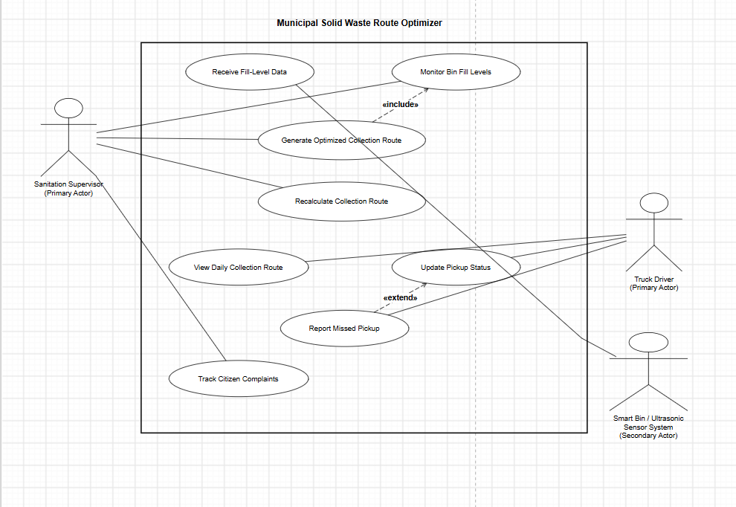

3. Main Success Scenario & Alternate Flow

Use Case Name: Generate Optimized Collection Route
Preconditions
- Smart bins are registered in the system.
- Fill-level data is available from the smart bins.
- The Sanitation Supervisor is logged into the system.
- Truck information is available.
Main Success Scenario
- Sanitation Supervisor logs into the system.
- System retrieves the latest fill-level data from smart bins.
- System identifies bins that have exceeded 80% fill level.
- System checks available trucks.
- System calculates an optimized collection route.
- System generates the daily collection route.
- Sanitation Supervisor reviews and confirms the route.
- System sends the confirmed route to the assigned Truck Driver.
- Truck Driver views the route and begins collection.
Alternate Flow
- If fill-level data for a bin is unavailable, the system marks that bin's data as unavailable.
- The system continues route generation using the latest valid data.
- The Sanitation Supervisor is notified about the unavailable data.
- The Supervisor can manually tag the bin if it needs immediate collection.
Postconditions
- An optimized daily collection route is generated.
- Eligible bins above 80% fill are included.
- The confirmed route is available to the Truck Driver.
- Any bins with unavailable data are reported to the Sanitation Supervisor.

3. Main Success Scenario & Alternate Flow
Use Case Name: Generate Optimized Collection Route
Preconditions
- Smart bins are registered in the system.
- Fill-level data is available from the smart bins.
- The Sanitation Supervisor is logged into the system.
- Truck information is available.
Main Success Scenario
- Sanitation Supervisor logs into the system.
- System retrieves the latest fill-level data from smart bins.
- System identifies bins that have exceeded 80% fill level.
- System checks available trucks.
- System calculates an optimized collection route.
- System generates the daily collection route.
- Sanitation Supervisor reviews and confirms the route.
- System sends the confirmed route to the assigned Truck Driver.
- Truck Driver views the route and begins collection.
Alternate Flow
- If fill-level data for a bin is unavailable, the system marks that bin's data as unavailable.
- The system continues route generation using the latest valid data.
- The Sanitation Supervisor is notified about the unavailable data.
- The Supervisor can manually tag the bin if it needs immediate collection.
Postconditions
- An optimized daily collection route is generated.
- Eligible bins above 80% fill are included.
- The confirmed route is available to the Truck Driver.
- Any bins with unavailable data are reported to the Sanitation Supervisor

Actors & Use Cases

Primary Actors:
- Sanitation Supervisor — manages bin information, generates/recalculates routes, and tracks citizen complaints.
- Truck Driver — views assigned routes, updates pickup status, and reports missed pickups.
Secondary Actor:
- Smart Bin / Ultrasonic Sensor System — provides ultrasonic fill-level data to the system.
Use Cases
- Receive Fill-Level Data
- Monitor Bin Fill Levels
- Generate Optimized Collection Route
- Recalculate Collection Route
- View Daily Collection Route
- Update Pickup Status
- Report Missed Pickup
- Track Citizen Complaints
UML Relationships
- Generate Optimized Collection Route «include» Monitor Bin Fill Levels
- Report Missed Pickup «extend» Update Pickup Status

